OFFICIAL NOTIFICATION FOR
NON-ROUTINE OPERATIONS AND MAINTENANCE

NOTIFICATION DATE- 31 March 2010
PROJECT- The Dalles
RESPONSE DATE- No response required, but comments are always welcome.

Description of the problem- BPA plans to take transformers T2 out on Apr8 for maintenance. In order to safely back feed to T1, Fish units must be de-energized.

Type of outage required- Fish units 1 and 2 off with no attraction water supply to the east fishway.

Impact on facility operation- Fish units

Length of time for repairs- 1/2hr

Expected impacts on fish passage- Present Bonneville counts have been ~50 chinook per day to date. At Historically at The Dalles, steelhead average ~50 per day through April and Chinook steadily increase through April. We’ll have a better idea when fish counting starts Apr1 at The Dalles. Given that the outage is only 1/2hr and will occur in the evening, passage impact is expected to be minimal.

Comments from agencies-
USFWS- This is listed as a non-routine operation, so I'm assuming this really needs to get done. Based on the shut down time of 30 minutes, the low adult passage at this time, and the apparent down time being at night, I have no objections. However, it is only offhandedly remarked in the Expected impacts on fish passage- section that the shut down does occur at night, like we were already suppose to know that. The expected time of the outage should be clearly stated on the coordination form. At what time, exactly, is the shutdown expected to occur? David Wills
TDA- Given all the steps required in the process, they weren't able to provide an exact time. Guestimate was ~7PM.

Final results- The outage will go forward as noted in this memo.

Tammy Mackey
NWP Operations Division Fishery Section
Columbia River Coordination Biologist
541-374-4552 Bonneville Office
503-961-5733 Blackberry
Tammy.m.mackey@usace.army.mil

J, K, L, M
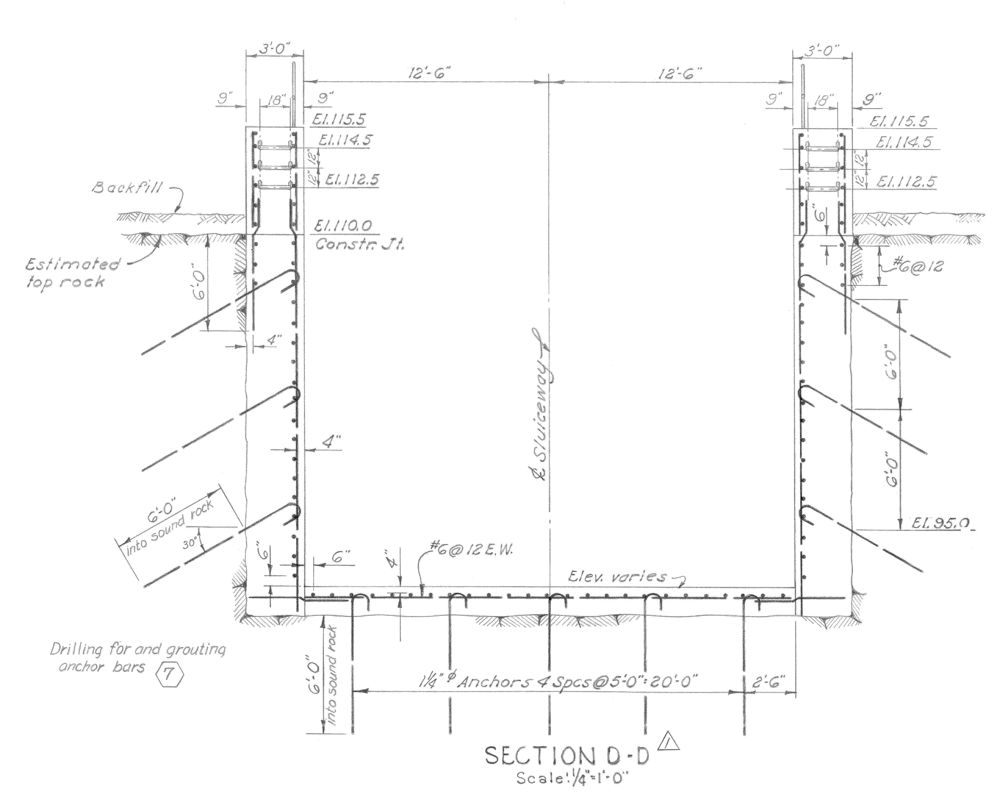

F
G
H
I
N
B,C,D,E
F
J,K,L,M
El. 85
P/Q Contact Zone
Grout Zone 2
El. 80

Primary Grout Holes

Secondary Grout Holes

Date: 1/22/10
From: Bob Cordie, Project Biologist, The Dalles Dam

Re; Contingency plan for The Dalles east fishway, south channel operation in the Westrick park oil spill recovery efforts

With the transformer spill in Westrick Park at close proximity to the south fishway channel, an unknown quantity of oil may be in the substrate in the immediate area. To date, no oil sheen has been observed in the channel. Close monitoring continues. There is a possibility of oil migrating into the channel during fish passage season, several months after the spill recovery efforts. Therefore this contingency plan will be presented as an alternative operation to allow oil recovery efforts.

Increased fishway inspection observations will be conducted immediately after the east fishway is returned to service to catch any oil sheen. This will be done during optimal lighting conditions at the Westrick building bridge and the south entrance area. If oil sheen is noted, the project ECC will immediately be notified.

If it is determined the volume of oil needs to be contained, the following operation may be implemented pending approval from regional fish managers.
- Shut down Fish unit 1 and 2.
- Install isolation bulkheads between powerhouse and south channel. This includes auxiliary water conduit bulkhead and channel bulkhead.
- Install south entrance bulkheads to isolate channel from river.
- Crane setup and structural prep work must be completed prior to fish unit shut down.
- Open all west and east entrance weirs to full open.
- Return fish unit operation to half load and slowly increase while monitoring east and west entrance flows.
- Maintain this operation during oil recovery efforts.

Fish Passage Data
Blue bars are flow percent flow volume. Maroon bars are percent passage.

Potential flow and fish passage affect;
South entrance passage ranges from 10-25% depending on species. South entrance flow is approximately 40% of total. If south entrance is closed, the 40% flow will be added to east and west entrances. However due to potential added pressure on fishway grating on east and west, the full 40% may not be used.
With added flow to the east and west, it’s possible the 10-25% south passage may be distributed to east and west without added overall dam passage delay. University of Idaho telemetry would be needed to verify potential overall passage delay.

